Deccan Education Society’s
Fergusson College (Autonomous), Pune
Department of Computer Science

A

Report

on

“K-Neighbors-Classifier”

In partial fulfillment of Post Graduate course

in

M.Sc. Computer Science – I

(Semester -II)

2024-2025

CSC-570 Practical III

SUBMITTED BY

Dhimar Arin Avinash (246203)

Index

Sr. No | Table of Content | Page No
1 | Case Study description | 3
2 | Screenshots | 4
3 | References | 7

- Case Study description
    - K-Means Implementation:
        - Steps visualized: Initialization, Assignment, Centroid Recalculation, and Convergence
        - Dynamic cluster statistics (mean, standard deviation, min/max values)
        - Real-time animation of centroid movement and point assignments
        - Support for custom cluster counts (K=2 to K=10)
        - CSV data import/export functionality
    - UI Design Details
        - Component Architecture:
            - DataEntryPanel: Handles data input (manual entry/CSV upload/random generation)
            - DataVisualizationPanel: Manages scatter plots, bar charts, and cluster statistics
            - ClusterStats: Displays statistical summaries for each cluster
            - FloatingControls: Interactive animation playback controlsScreenshots
        - Key Features:
            - Dark/light mode support
            - Keyboard shortcuts for animation control (Space, Arrows, Home/End)
            - Responsive pagination for data tables
            - Color-coded cluster visualization
        - Tech Stack:
            - React + Vite (Frontend Framework)
            - Tailwind CSS (Styling)

            - Lucide React (Icons)
            - HTML5 Canvas (Visualizations)
- Screenshots
    - Data Entry Interface: Showcasing CSV upload and manual data entry controls
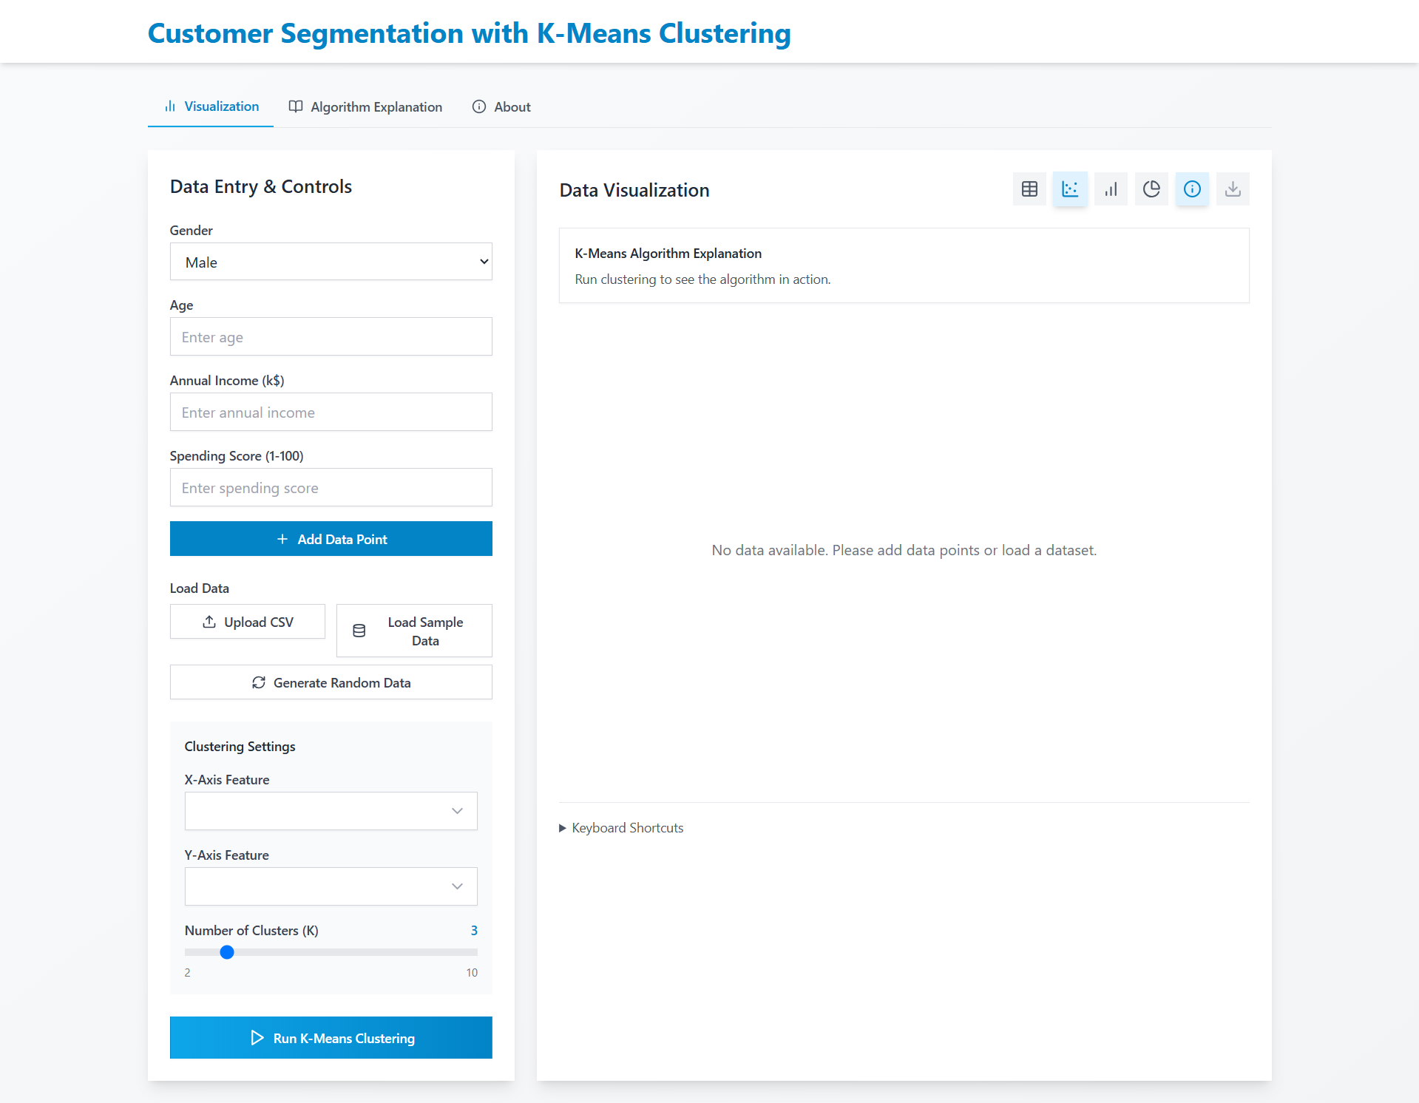
    - Clustering Visualization: Scatter plot with centroids and cluster boundaries
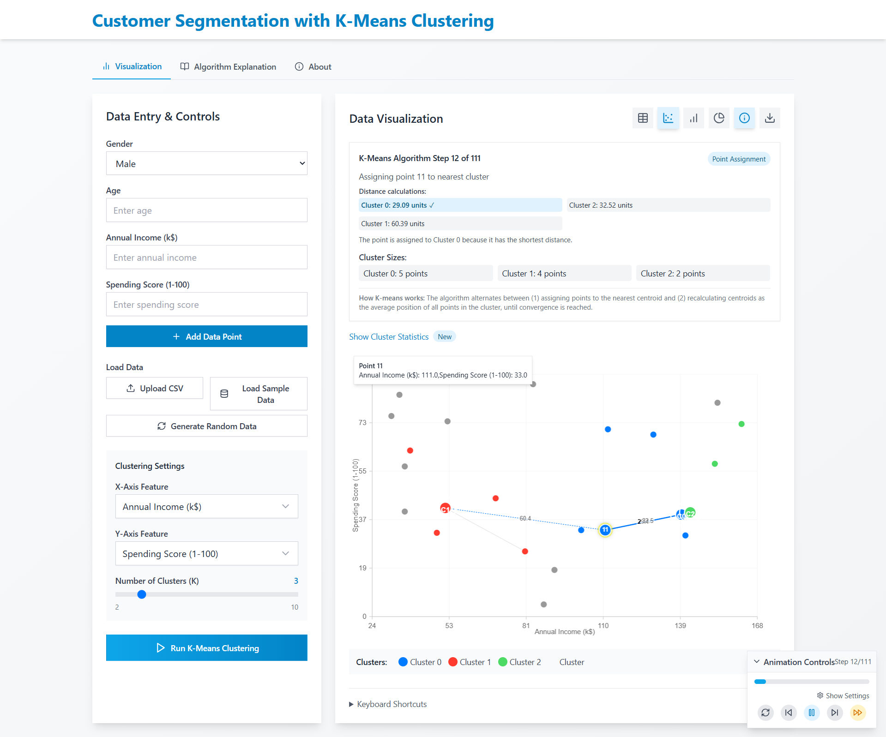

    - Cluster Statistics: Expanded view of mean/std dev calculations
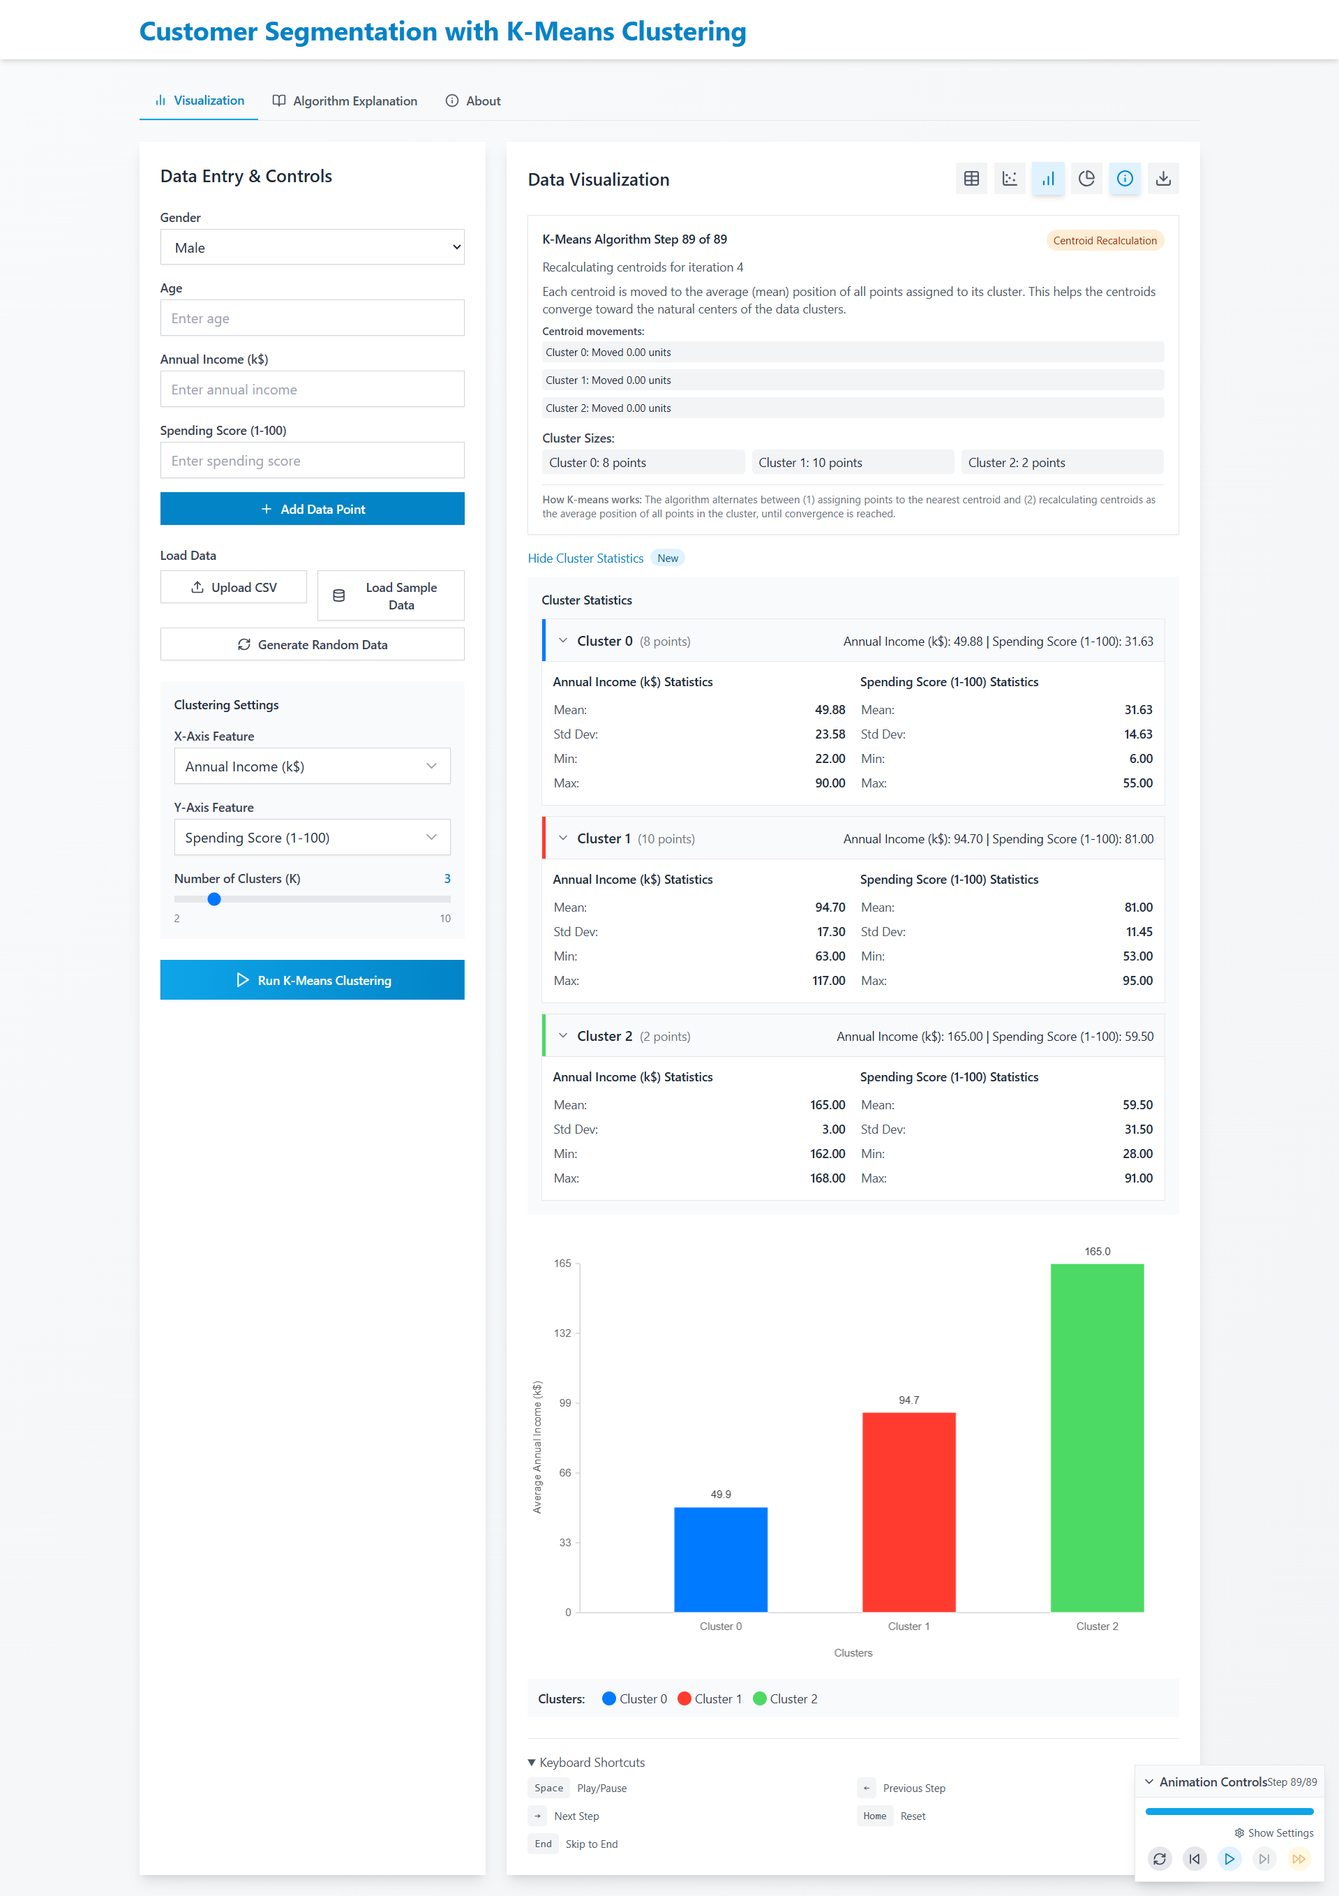

    - Algorithm Explanation: Step-by-step breakdown of K-Means iterations
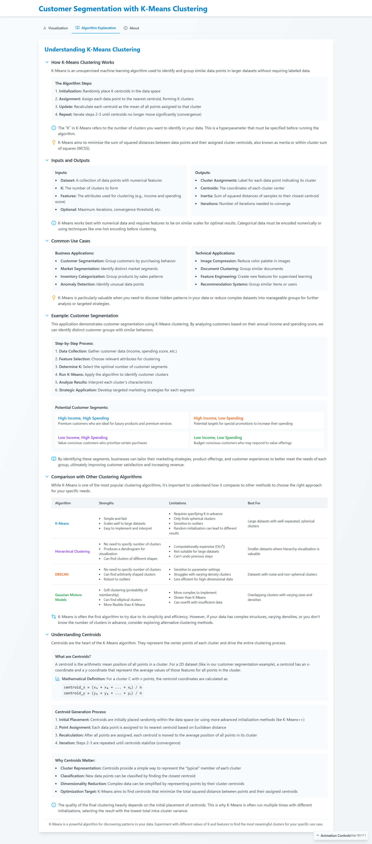

    - Data Table: Paginated view with cluster assignments
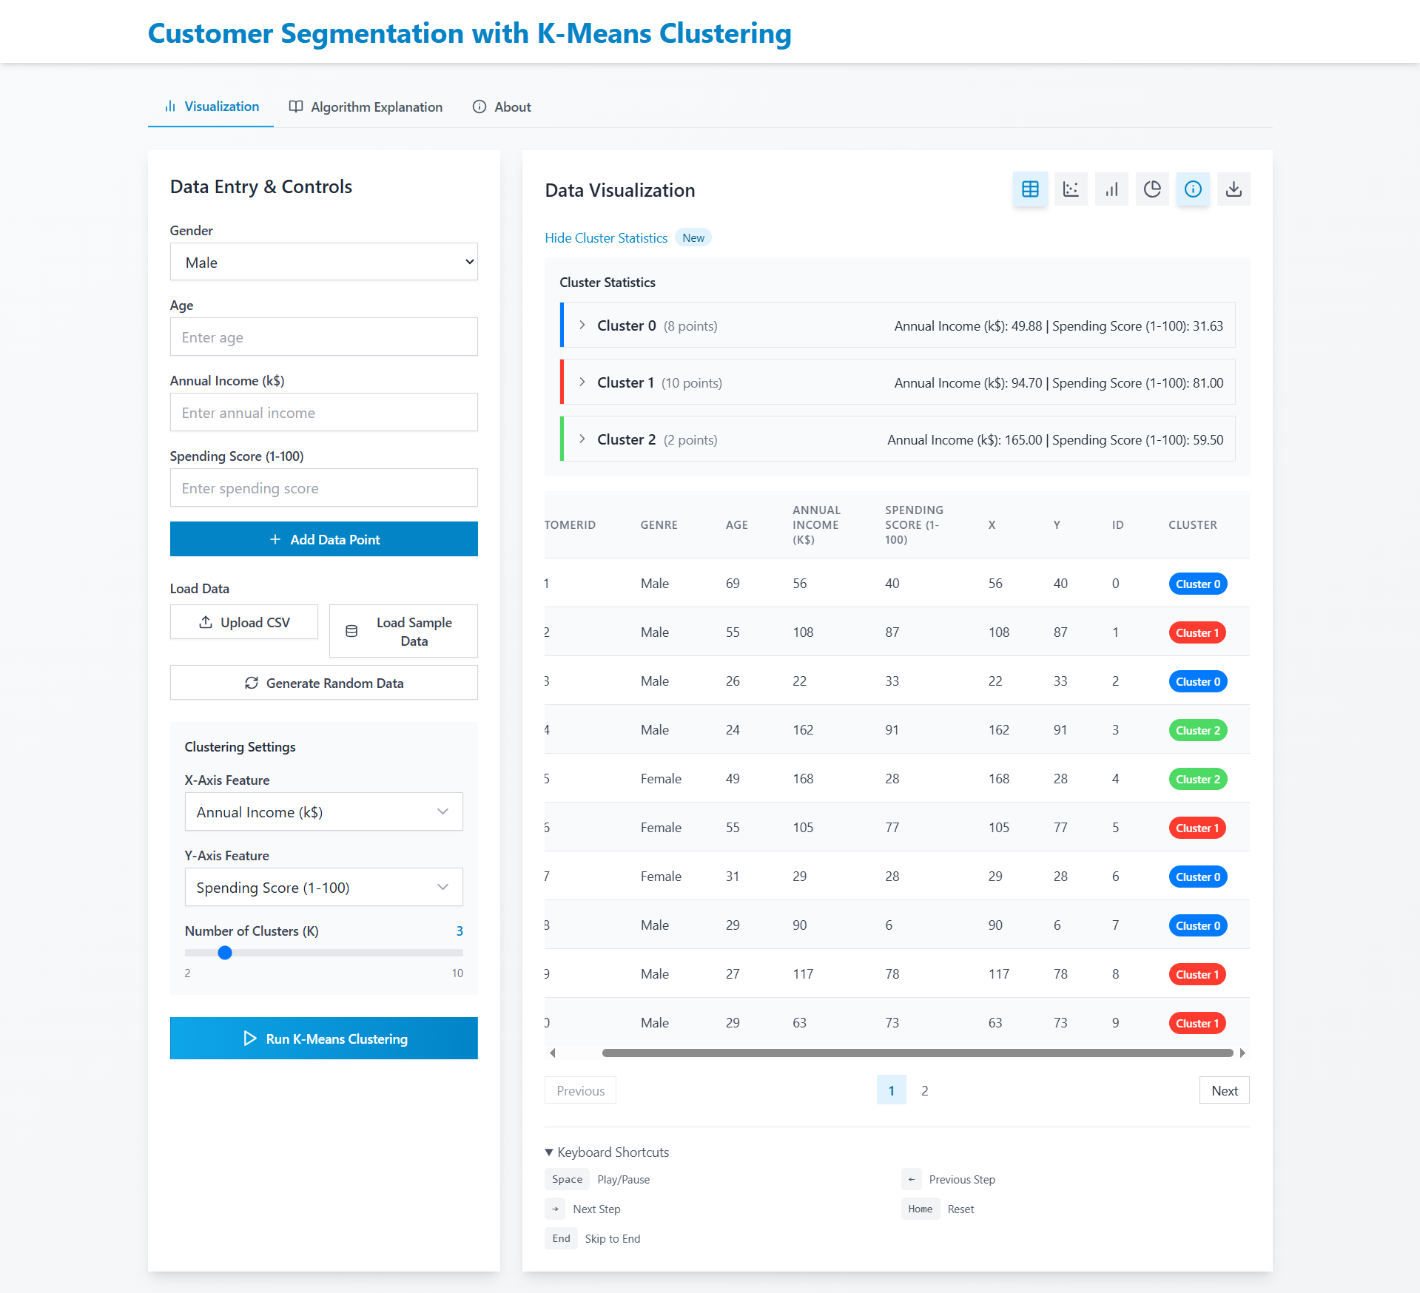
- References
    - Lucide Icons: https://lucide.dev/
    - Tailwind CSS: https://tailwindcss.com/
    - K-Means Algorithm: "An Introduction to Statistical Learning" (James et al.)
    - React Documentation: https://react.dev/
    - CSV Parsing: Papa Parse Library (implied from code context)

